Name : Sundaramoorthy S
Reg No : 192324228
Course code : Cloud Computing And Big Data Analysis
Exp No : EXPERIMENT 4
Date : 18/12/2025

EXPERIMENT 4
Title
Creation of a Simple Cloud Software Application for Car Booking Reservation System to Demonstrate SaaS
Aim
To develop and deploy a cloud-based Car Booking Reservation System using a Cloud Service Provider to demonstrate Software as a Service (SaaS).
Procedure
- Select a suitable cloud service provider.
- Create a web application for car booking and reservation.
- Design forms for car details, customer details, and booking information.
- Store booking data in a cloud database.
- Deploy the application on cloud infrastructure.
- Enable users to access the application through a web browser.
Sample Dataset
- Car ID: C001, Model: Swift, Type: Hatchback, Price/Day: 2000
- Car ID: C002, Model: Innova, Type: SUV, Price/Day: 3500
Output
- Car booking form available online.
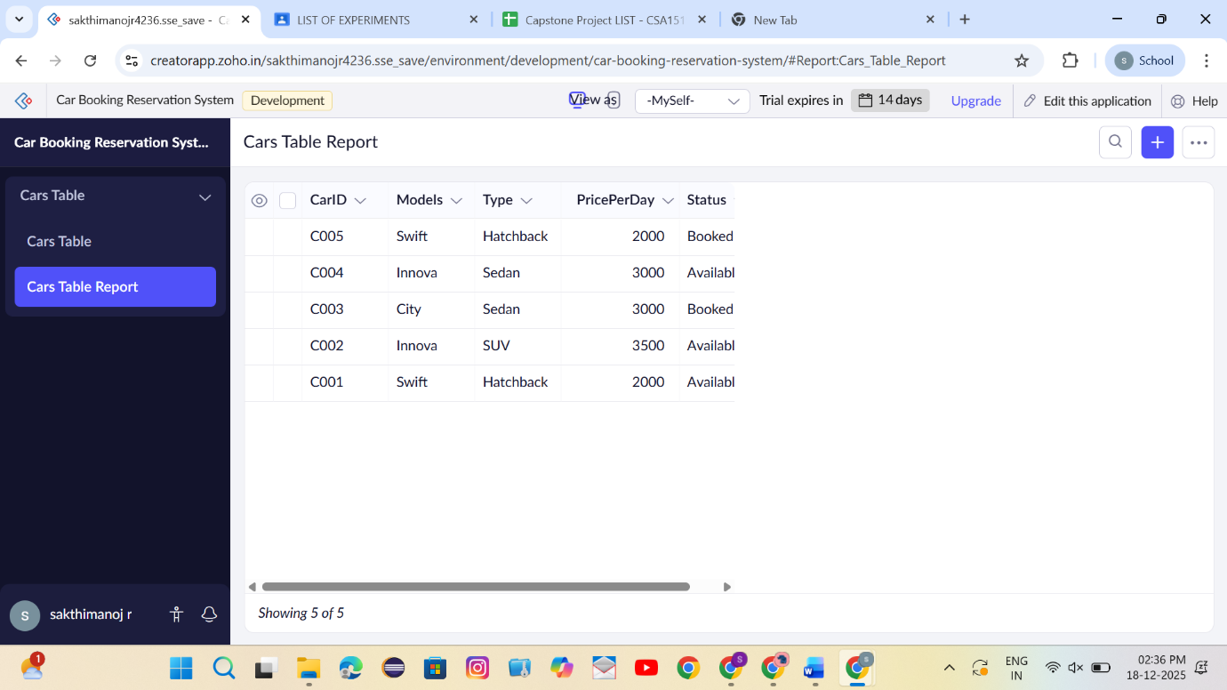

- Booking details stored in cloud database.
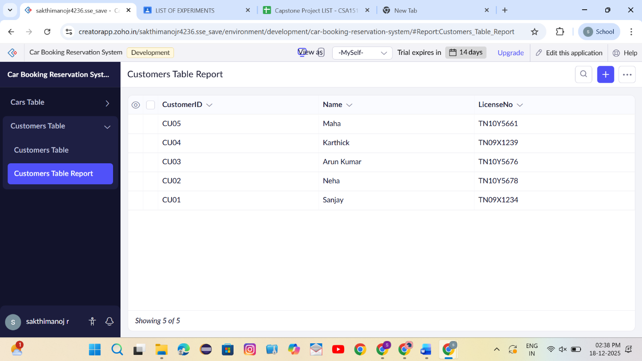
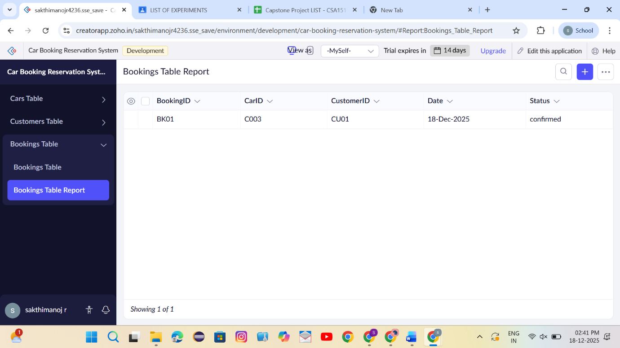
Result
Thus, a simple cloud-based Car Booking Reservation System was successfully implemented and deployed to demonstrate SaaS.

